# BI Solution Assignment

## Part A

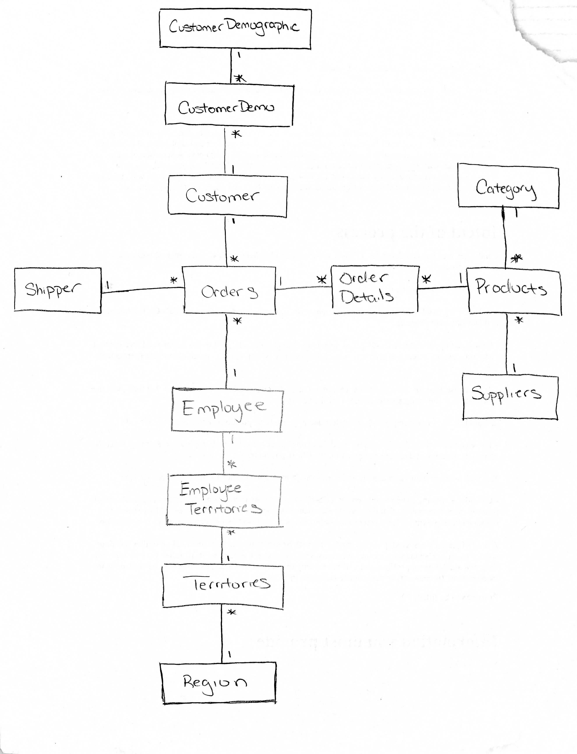

|  |  |
| --- | --- |
| Categories | |
| <<PK>> | CategoryID: Number {CategoryID > 0}  CategoryName: Character {size=15}  Description: String [0..1]  Picture: Image [0..1] |

|  |  |
| --- | --- |
| CustomerCustomerDemo | |
| <<PK>><<FK>>  <<PK>><<FK>> | CustomerID: Character {size=5} {reference = Customers, key = PK, order 1}  CustomerTypeID: Character {size=10} {reference = CustomerDemographics, key = PK, order=2} |

|  |  |
| --- | --- |
| CustomerDemographics | |
| <<PK>> | CustomerTypeID: Character {size=10}  CustomerDesc: String [0..1] |

|  |  |
| --- | --- |
| Customers | |
| <<PK>> | CustomerID: Character {size=5}  CompanyName: Character {size=40}  ContactName: Character [0..1] {size=30}  ContactTitle: Character [0..1] {size=30}  Address: Character [0..1] {size=60}  City: Character [0..1] {size=15}  Region: Character [0..1] {size=15}  PostalCode: Character [0..1] {size=10}  Country: Character [0..1] {size=15}  Phone: Character [0..1] {size=24}  Fax: Character [0..1] {size=24} |

|  |  |
| --- | --- |
| Employees | |
| <<PK>>  <<FK>> | EmployeeID: Number {EmployeeID > 0}  LastName: Character {size=20}  FirstName: Character {size=10}  Title: Character [0..1] {size=30}  TitleOfCourtesy: Character [0..1] {size=25}  BirthDate: Date [0..1]  HireDate: Date [0..1]  Address: Character [0..1] {size=60}  City: Character [0..1] {size=15}  Region: Character [0..1] {size=15}  PostalCode: Character [0..1] {size=10}  Country: Character [0..1] {size=15}  HomePhone: Character [0..1] {size=24}  Extension: Character [0..1] {size=4}  Photo: Image [0..1]  Notes: String [0..1]  ReportsTo: Number [0..1] {ReportsTo > 0} {reference = Employees}  PhotoPath: Character [0..1] {size=255} |

|  |  |
| --- | --- |
| EmployeeTerritories | |
| <<PK>><<FK>>  <<PK>><<FK>> | EmployeeID: Number {EmployeID > 0} {reference = Employees, key=PK, order=1}  TerritoryID: Number {TerrirtoryID >0} {reference = Territories, key=PK, order=2} |

|  |  |
| --- | --- |
| OrderDetails | |
| <<PK>><<FK>>  <<PK>><<FK>> | OrderID: Number {OrderID > 0} {reference = Orders, key=PK, order=1}  ProductID: Number {NumberID > 0} {reference = Products, key=PK, order=2}  UnitPrice: Money {UnitPrice >=0}  Quanity: Number {Quanity >0}  Discount: Number {Discount >=0} |

|  |  |
| --- | --- |
| Orders | |
| <<PK>>  <<FK>>  <<FK>>  <<FK>> | OrderID: Number {OrderID > 0}  CustomerID: Character [0..1] {size=5} {reference = Customers}  EmployeeID: Number {EmployeeID > 0} {reference = Employees}  OrderDate: Date [0..1]  RequiredDate: Date [0..1]  ShippedDate: Date [0..1]  ShipVia: Number [0..1] {ShipVia > 0} {reference = Shippers}  Freight: Money [0..1] {Freight >=0}  ShipName: Character [0..1] {size=40}  ShipAddress: Character [0..1] {size=60}  ShipCity: Character [0..1] {size15}  ShipRegion: Character [0..1] {size=15}  ShipPostalCode: Character [0..1] {size=10}  ShipCountry: Character [0..1] {size=15} |

|  |  |
| --- | --- |
| Products | |
| <<PK>>  <<FK>>  <<FK>> | ProductID: Number {ProductID > 0}  ProductName: Character {size=40}  SupplierID: Number [0..1] {SuppliedID > 0} {reference=Suppliers}  CategoryID: Number [0..1] {CategoryID > 0} {reference=Categories}  QuanityPerUnit: Character [0..1] {size=20}  UnitPrice: Money [0..1] {UnitPrice >= 0}  UnitsInStock: Number [0..1] {UnitsInStock >= 0}  UnitsOnOrder: Number [0..1] {UnitsOnOrder >= 0}  RecorderLevel: Number [0..1] {RecorderLevel >=0}  Discontinued: Boolean |

|  |  |
| --- | --- |
| Region | |
| <<PK>> | RegionID: Number {RegionID > 0}  RegionDescription: Character {size=50} |

|  |  |
| --- | --- |
| Shippers | |
| <<PK>> | ShipperID: Number {ShipperID > 0}  CompanyName: Character {size=40}  Phone: Character [0..1] {size=24} |

|  |  |
| --- | --- |
| Suppliers | |
| <<PK>> | SupplierID: Number {SupplierID > 0}  CompanyName: Character {size=40}  ContactName: Character [0..1] {size=30}  ContactTitle: Character [0..1] {size=30}  Address: Character [0..1] {size=60}  City: Character [0..1] {size=15}  Region: Character [0..1] {size=15}  PostalCode: Character [0..1] {size=10}  Country: Character [0..1] {size=15}  Phone: Character [0..1] {size=24}  Fax: Character [0..1] {size=24}  HomePage: String [0..1] |

|  |  |
| --- | --- |
| Terrirtories | |
| <<PK>>  <<FK>> | TerritoryID: Character {size=20}  TerritoryDescription: Character {size=50}  RegionID: Number {RegionID > 0} {reference= Region} |

## Part B – Data Mart

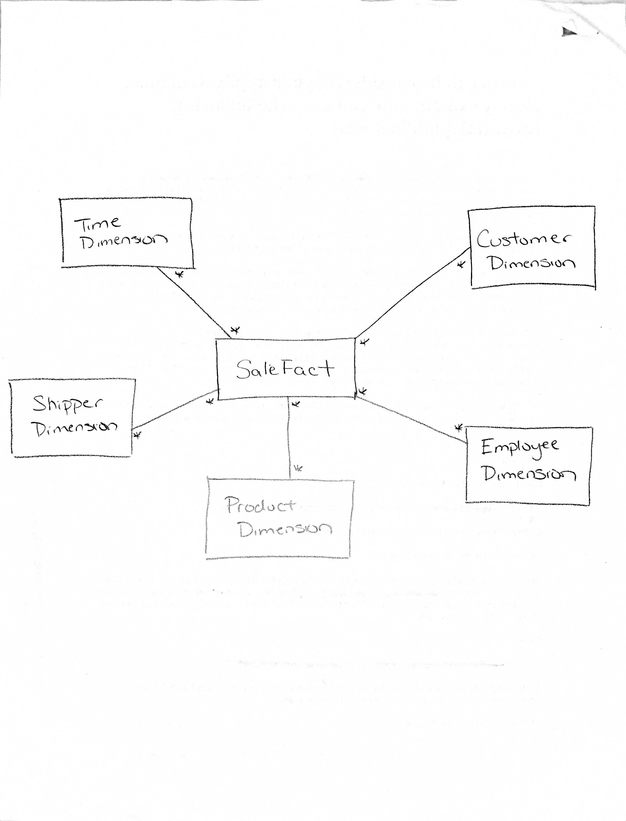

|  |  |
| --- | --- |
| CustomerDimension | |
| <<PK>> | CustomerKey: Number {CustomerKey > 0}  CompanyName: Character {size=40}  CustomerID: Character {size = 5}  ContactName: Character {size=30}  ContactTitle: Character {size=30}  Address: Character {size=60}  City: Character {size=15}  Region: Character {size=15}  PostalCode: Character {size=10}  Country: Character {size=15}  Phone: Character {size=24}  Fax: Character {size=24} |

|  |  |
| --- | --- |
| EmployeeDimension | |
| <<PK>> | EmployeeKey: Number {EmployeeKey > 0}  EmployeeName: Character {size=31}  EmployeeID: Number {EmployeeID > 0}  HireDate: Date |

|  |  |
| --- | --- |
| ProductDimension | |
| <<PK>> | ProductKey: Number {ProductKey > 0}  ProductName: Character {size=40}  ProductID: Number {ProductID > 0}  SupplierName: Character {size=40}  CategoryName: Character {size=15}  ListUnitPrice: Money {ListUnitPrice >= 0} |

|  |  |
| --- | --- |
| ShipperDimension | |
| <<PK>> | ShipperKey: Number {ShipperKey > 0}  ShipperName: Character {size=40}  ShipperID: Number {ShipperID >0} |

|  |  |
| --- | --- |
| TimeDimension | |
| <<PK>> | TimeKey: Number {TimeKey > 0}  TheDate: Date  DayOfWeek: Number {DayOfWeek >= 1 and DayOfWeek <= 7}  DayOfWeekName: Character {size=10}  Month: Number {Month >=1 and Month <=12}  MonthName: Character {size=10}  Year: Number {Year <= 0}  Quarter: Number {Quarter >=1 and Quarter <=4}  DayOfYear: Number {DayOfYear >= 1 and DayOfYear <=366}  Weekday: Character {size=1}  WeekOfYear: Number {WeekOfYear >= 1 and WeekOfYear <= 52} |

|  |  |
| --- | --- |
| SaleFact | |
| <<PK>><<FK>>  <<PK>><<FK>>  <<PK>><<FK>>  <<PK>><<FK>>  <<PK>><<FK>> | CustomerKey: Number {CustomerKey > 0} {reference = CustomerDimension, key=PK, order =1}  EmployeeKey: Number {EmployeeKey > 0} {reference = EmployeeDimension, key=PK, order=2}  ProductKey: Number {ProductKey > 0} {reference = ProductDimension, key=PK, order=3}  ShipperKey: Number {ShipperKey > 0} {reference = ShipperDimension, key=PK, order 4}  TimeKey: Number [1]{TimeKey > 0} {reference = TimeDimension, key=PK, order 5}  RequiredShipmentDate: Date  LineItemQuantity: Number {LineItemQuantity >= 0}  LineItemDiscount: Number {LineItemDiscount >=0 }  LineItemFreight: Money {LineItemFreight >=0}  LineItemTotal: Money {LineItemTotal >=0} |

CREATE DATABASE NorthwindDataMart;

CREATE TABLE CustomerDimension (

CustomerKey SMALLINT IDENTITY (1,1) PRIMARY KEY NONCLUSTERED,

CompanyName NVARCHAR(40) NOT NULL,

CustomerID NCHAR(5) NOT NULL,

ContactName NVARCHAR(30),

ContactTitle NVARCHAR(30),

[Address] NVARCHAR(60),

City NVARCHAR(15),

Region NVARCHAR(15),

PostalCode NVARCHAR(10),

Country NVARCHAR(15),

Phone NVARCHAR(24),

Fax NVARCHAR(24)

)

CREATE TABLE EmployeeDimension(

EmployeeKey TINYINT IDENTITY (1,1) PRIMARY KEY NONCLUSTERED,

EmployeeName NVARCHAR(31) NOT NULL,

EmployeeID TINYINT CHECK (EmployeeID > 0) NOT NULL,

HireDate DATE

)

CREATE TABLE ProductDimension(

ProductKey SMALLINT IDENTITY (1,1) PRIMARY KEY NONCLUSTERED,

ProductName NVARCHAR(40) NOT NULL,

ProductID SMALLINT CHECK (ProductID > 0) NOT NULL,

SupplierName NVARCHAR(40) NOT NULL,

CategoryName NVARCHAR(15) NOT NULL,

ListUnitPrice MONEY CHECK (ListUnitPrice >= 0)

)

CREATE TABLE ShipperDimension(

ShipperKey TINYINT IDENTITY (1,1) PRIMARY KEY NONCLUSTERED,

ShipperName NVARCHAR(40) NOT NULL,

ShipperID TINYINT CHECK (ShipperID > 0) NOT NULL

)

CREATE TABLE TimeDimension(

TimeKey INT IDENTITY (1,1) PRIMARY KEY NONCLUSTERED,

TheDate DATE NOT NULL,

[DayOfWeek] TINYINT CHECK ([DayOfWeek] >= 1 AND [DayOfWeek] <=7),

DayOfWeekName VARCHAR(10),

[Month] TINYINT CHECK ([Month] >=1 and [Month] >= 12),

[MonthName] VARCHAR(10),

[Year] SMALLINT CHECK ([Year]<=0),

[Quarter] TINYINT CHECK ([Quarter] >=1 AND [Quarter]<=4),

[DayOfYear] TINYINT CHECK ([DayOfYear]>=1 AND [DayOfYear]<=366),

[Weekday] CHAR(1),

[WeekOfYear] TINYINT CHECK ([WeekOfYear]>=1 AND [WeekOfYear]<=52)

)

CREATE TABLE SaleFact(

CustomerKey SMALLINT CHECK (CustomerKey>0) FOREIGN KEY REFERENCES CustomerDimension(CustomerKey),

EmployeeKey TINYINT CHECK (EmployeeKey>0) FOREIGN KEY REFERENCES EmployeeDimension(EmployeeKey),

ProductKey SMALLINT CHECK (ProductKey>0) FOREIGN KEY REFERENCES ProductDimension(ProductKey),

ShipperKey TINYINT CHECK (ShipperKey>0) FOREIGN KEY REFERENCES ShipperDimension(ShipperKey),

TimeKey INT CHECK (Timekey>0) FOREIGN KEY REFERENCES TimeDimension(TimeKey),

RequiredShipmentDate DATE NOT NULL,

LineItemQuantity INT CHECK (LineItemQuantity>=0) NOT NULL,

LineItemDiscount REAL CHECK (LineItemDiscount >=0) NOT NULL,

LineItemFreight MONEY CHECK (LineItemFreight >=0) NOT NULL,

LineItemTotal MONEY CHECK (LineItemTotal >=0) NOT NULL,

PRIMARY KEY (CustomerKey, Employeekey, ProductKey, ShipperKey, TimeKey)

)

CREATE NONCLUSTERED INDEX SaleFactIndex ON SaleFact(

CustomerKey,

EmployeeKey,

ProductKey,

ShipperKey,

TimeKey)